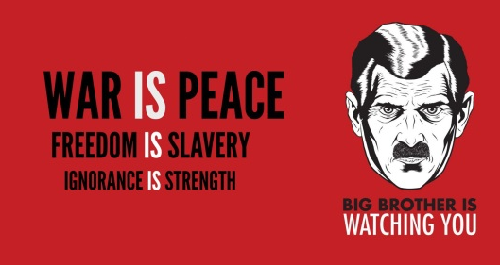
Year 6 ELLSL
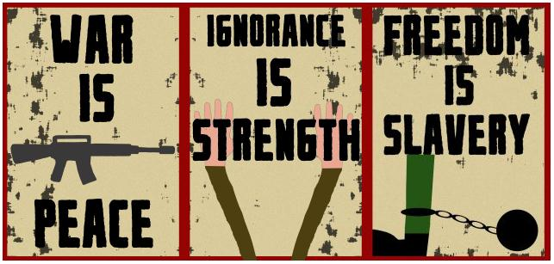
Paper 2 Writing Trail

Objectives:

- To review exemplar Paper 2 essays.
- To time yourself carefully and complete tasks in the allocated time.
- To draft a clear outline.
- To select relevant evidence to show knowledge and understanding of the work and context.
- To learn how unpack the exam question and produce a clear and relevant response.
- To explain and evaluate the writers’ use of stylistic features
- To produce a structurally sound essay with clear developed arguments
- To use clear, varied and accurate language.

Starter (10 minutes):
- Read through your essay and read the teacher feedback carefully.
- Read through the success criteria feedback.
- Make a note of what you need to do to improve your essay.
- Read the lesson objectives and compare with the assessment rubric.

Areas for improvement:

Activity 1- Selecting and unpacking a question

10 minutes

May 2016

- Identify some of the forms intolerance can take, and discuss how its effects on both the victims and the intolerant are presented in the two works you have studied.

- Often the appeal for the reader of a literary work is the atmosphere a writer creates (for example, peaceful, menacing or ironic). Discuss some of the ways atmospheres are conveyed and to what effect in the two works you have studied.

- Writers often choose words, phrases and names of characters and places not only for their literal meaning, but for further meanings that they may suggest to the reader. With reference to the two works you have studied, discuss how such words and their associations contribute to your understanding and appreciation of the works.

- In what way(s) can the term “artificial” be applied to the two works you have studied?

- Referring to the two works you have studied, discuss both how and why the text invites the reader to identify with situations, characters and/or ideas.

- How is “home” depicted in the two works you have studied and what is its significance?

May 2017

- How and why might the two works you have studied be considered inspirational?

- How do the writers of the two works you have studied convey a sense of place to their readers and to what purpose?

- To what extent do the two literary works you have studied show that an individual is in control of his or her own destiny?

- How can examining a literary work from a different perspectives enrich our understanding of both the work and the techniques used by the writer? Base your answer on the two works you have studied.

- Analyse the role non-human elements play in the two works you have studied.

- Some say ignorance is bliss. How is “not knowing” presented in the two works you have studied and to what effect?

Select one essay question. Do not pick the same one you chose for your September assignment.

Things to take into account when selecting a question:

- Remember Paper 2 is requiring to do 3 things:
  - Be knowledgeable on the text and context.
  - Answers the exam question in a focused way.
  - Comment on the author use of language, style and structure.

- Some question are more criteria focused. This means you will start with the obvious criteria but you still need to make sure you address most criteria. For example: “Explain why your literary work are timeless” will lend itself to an in-depth discussion of context of production and reception.

- Underline key words. If there is more than one sentence identify clearly which part is a question and which part may just be a stimulus to get you started. Consider question 6 (May 2017). Which part of the exam question should you focus on?

- Planning is a MUST. Devote 10 to 15 minutes to writing an outline.

Task:
Literary devices, style and structure:
- circle the exam question you chose.
- Highlight the key words
- Complete the brainstorming map with everything you can think of.
Themes:
- Power

Context:
Question number: May 2016 Q3

Key words in the question:

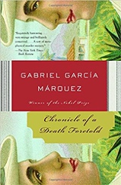

Activity 2- Planning an outline

15 minutes

- We use outlines to prevent 'after thoughts' from creeping into the essay. Examiners find it difficult to read scripts that include, boxes, arrows and symbols that attempt to insert text that was written as an after thought. Once you see an overview of your ideas, you can move them around more easily.
- We use outlines to ensure that all the criteria are met, all works are explored equally and ideas appear in the logical order.
- A good outline can save you time for the reasons mentioned above.

There are 3 possible outlines:

- Comparative: you make a point and then explore how the point applies to both works of literature.
- Side by side: You write 3 to 4 paragraphs on one novel, then move on to the next one.
- Criterion based: You write one paragraph to show you know the story and context, one with key words form the question, one that specifically name stylistic features.

Complete the outline table in 10 minutes.

Introduction

Get to the point name the key words from the question you selected and what they will mean to you in this essay. | Words, phrases, names of character and places  Literal and further meaning
Present the two works and authors.

Present a simple clear thesis.

Body (comparative)

Point 1: Your main idea that answers the question considering the first work
Evidence: Quotes and paraphrase from work 1.
Analysis & Explanation: What do we learn about context, style, language, themes or context?
Point 1: Your main idea that answers the question considering the second work
Evidence: Quotes and paraphrase from work 2.
Analysis & Explanation: What do we learn about context, style, language, themes or context?
Point 2: Your main idea that answers the question considering the first work
Evidence: Quotes and paraphrase from work 1.
Analysis & Explanation: What do we learn about context, style, language, themes or context?
Point 2: Your main idea that answers the question considering the second work
Evidence: Quotes and paraphrase from work 2.
Analysis & Explanation: What do we learn about context, style, language, themes or context?
Point 3: Your main idea that answers the question considering the first work
Evidence: Quotes and paraphrase from work 1.
Analysis & Explanation: What do we learn about context, style, language, themes or context?
Point 3: Your main idea that answers the question considering the second work
Evidence: Quotes and paraphrase from work 2.
Analysis & Explanation: What do we learn about context, style, language, themes or context?

Conclusion

Restate your thesis using other words

Final comparison of the two works

Thought provoking statement or wise words.

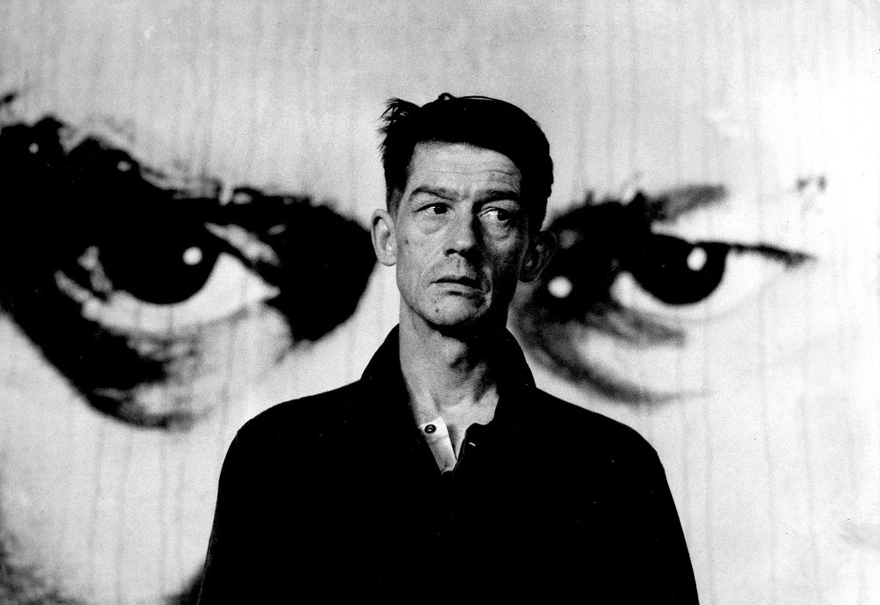

Body (Side-by-side)

Body (side-by-side)

Work 1

Point 1: Your main idea that answers the question considering the first work
Evidence: Quotes and paraphrase from work 1.
Analysis & Explanation: What do we learn about context, style, language, themes or context?
Point 2: Your main idea that answers the question considering the first work
Evidence: Quotes and paraphrase from work 1.
Analysis & Explanation: What do we learn about context, style, language, themes or context?
Point 3: Your main idea that answers the question considering the first work
Evidence: Quotes and paraphrase from work 1.
Analysis & Explanation: What do we learn about context, style, language, themes or context?
Work 2

Point 1: Your main idea that answers the question considering the second work
Evidence: Quotes and paraphrase from work 2.
Analysis & Explanation: What do we learn about context, style, language, themes or context?

Point 2: Your main idea that answers the question considering the second work
Evidence: Quotes and paraphrase from work 2.
Analysis & Explanation: What do we learn about context, style, language, themes or context?
Point 3: Your main idea that answers the question considering the second work
Evidence: Quotes and paraphrase from work 2.
Analysis & Explanation: What do we learn about context, style, language, themes or context?

Conclusion

Restate your thesis using other words

Final comparison of the two works

Thought provoking statement or wise words.

Activity 3- Writing the introduction

20 minutes

After planning, you should write your introductory paragraph.

This paragraph introduces and signposts your discussion or argument. Keep it brief, simple, and direct. It should contain a thesis statement. A thesis statement isn’t something complex; rather, it’s your main idea or argument, clearly expressed.

- 10 minutes- Read the following student introduction in pairs. Is it a good introduction? Why? What would you change?

“There have been men and women since the dawn of time. And they have always been different. In my English class, I’ve been reading a couple of decent books that are both about men and women. The first one, which happens in the 1960s is called Bell jar. It is written by Sylvia Plath and she committed suicide. The other book was written before bell Jar and is the magnificent, highly respected book about France called Madame Bovary. I’m going to talk about these books in my essay and why setting is important.”

- Now read the exemplar introduction on the following page.

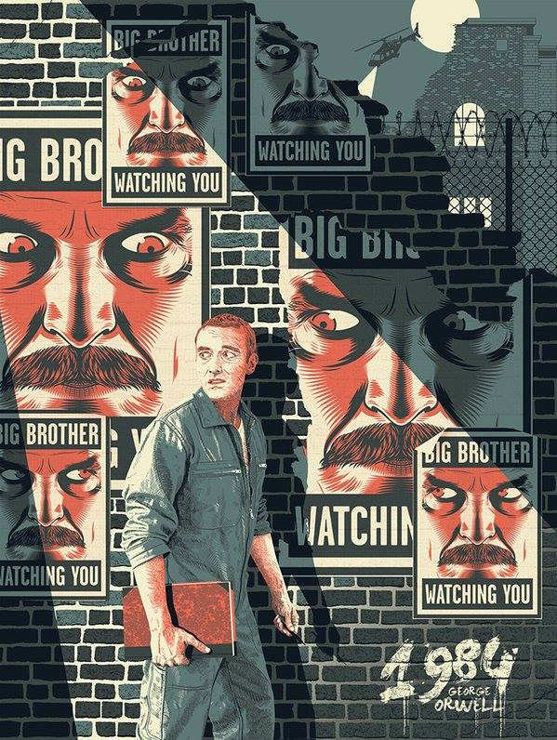

“Unable to find an authentic identity in the patriarchal society of 1950’s America, Esther Greenwood goes ‘mad’. Entrapped by her provincial existence in rural 1850’s Normandy, Emma Bovary expresses her desires in a series of passionate extra-marital affairs. Both Esther, the protagonist of Sylvia Plath’s bildungsroman The Bell Jar, and Emma, the protagonist of Gustave Flaubert’s eponymous, realist novel Madame Bovary are female characters who struggle to adapt in repressive, androcentric societies that thwart their attempts to establish an authentic identity. Esther becomes depressed, attempts suicide, but eventually recovers. Emma, by contrast, successfully commits suicide, repressed and dissatisfied with life. Both women struggle to conform to societal norms, and in each literary text, their problems are frequently expressed in the physical, cultural, and historical setting of each text.”

- Write your own introduction for the essay question you have chosen.

Activity 4- Selecting evidence and identify key stylistic features

10 minutes

Make a list of 2-3 stylistic features you may use in your essay. Write down the Evidence (paraphrase, quotation, summary) and the literary terms you may use.

Evidence | Literary term
“Ignorance is Strength” | Irony

Activity 5- Linking contextual analysis to the literary work

10 minutes

Remember you should be knowledgeable on the text and the context. However, you should not simply throw in contextual information. Instead you should make sure you link the contextual points you make to your literary analysis.

Fill in the table with one or two observation on context

Exam question | Information about context | How does this link to the literary work?
To what extent do the two literary works you have studied show that an individual is in control of his or her own destiny? | La Violencia- a civil conflict that lasted over a decade. Started as a political dispute but thrived on old rivalries and disputes especially in rural areas (land disputes, family feuds, social class). Cycle of violence became impossible to stop. No one clearly knew who started it. | In COADF, civil, political and judicial institutions and authority figures are shown as powerless to act and cannot avert violence (Mayor, priest & bishops, judge) just as institutions failed during La Violencia. Individuals are then compelled to take matters in their own hands regardless of whether they actually want to act. The twins want to be stopped yet they are taken in something far bigger than themselves just like the individuals in La Violencia.

Activity 6- Using effective paragraphs and addressing the exam question

10 minutes

Remember each paragraph must start with clear point. It should be apparent which aspect of the text you are discussing (themes, characterization, context)

POINT | EVIDENCE | ANALYSIS
The Red armed prole woman embodies Orwell’s political views and reflects his lifelong engagement documenting the plight of the English working class. | Physical description p228-229.  Orwell’s writing: The road to Wigan Pier 1937. Documenting the lifes of workers in poor coal mining communities in Northern England. | Prole=proletariat a Marxist term for the working class. Echoes Orwell’s socialist leanings and ideology.  Marxist/socialist ideology: revolution of the proletariat once they have achieved consciousness: echoed page  229 “Sooner or later it would happen, strength would change into consciousness.”

Map-out one of your paragraphs in notes:

POINT | EVIDENCE | ANALYSIS

Exam question:……………………………………………………………………………………………… ……………………………………………………………………………………………………………………………………………………………………………………………………………………………………

…………………………………………………………………………………………………………………………………………………………………………………………………………………………………………………………………………………………………………………………………………………………………………………………………………………………………………………………………………………………………………………………………………………………………………………………………………………………………………………………………………………………………………………………………………………………………………………………………………………………………………………………………………………………………………………………………………………………………………………………………………………………………………………………………………………………………………………………………………………………………………………………………………………………………………………………………………………………………………………………………………………………………………………………………………………………………………………………………………………………………………………………………………………………………………………………………………………………………………………………………………………………………………………………………………………………………………………………………………………………………………………………………………………………………………………………………………………………………………………………………………………………………………………………………………………………………………………………………………………………………………………………………………………………………………………………………………………………………………………………………………………………………………………………………………………………………………………………………………………………………………………………………………………………………………………………………………………………………………………………………………………………………………………………………………………………………………………………………………………………………………………………………………………………………………………………………………………………………………………………………………………………………………………………………………………………………………………………………………………………………………………………………………………………………………………………………………………………………………………………………………………………………………………………………………………………………………………………………………………………………………………………………………………………………………………………………………………………………………………………………………………………………………………………………………………………………………………………………………………………………………………………………………………………………………………………………………………………………………………………………………………………………………………………………………………………………………………………………………………………………………………………………………………………………………………………………………………………………………………………………………………………………………………………………………………………………………………………………………………………………………………………………………………………………………………………………………………………………………………………………………………………………………………………………………………………………………………………………………………………………………………………………………………………………………………………………………………………………………………………………………………………………………………………………………………………………………………………………………………………………………………………………………………………………………………………………………………………………………………………………………………………………………………………………………………………………………………………………………………………………………………………………………………………………………………………………………………………………………………………………………………………………………………………………………………………………………………………………………………………………………………………………………………………………………………………………………………………………………………………………………………………………………………………………………………………………………………………………………………………………………………………………………………………………………………………………………………………………………………………………………………………………………………………………………………………………………………………………………………………………………………………………………………………………………………………………………………………………………………………………………………………………………………………………………………………………………………………………………………………………………………………………………………………………………………………………………………………………………………………………………………………………………………………………………………………………………………………………………………………………………………………………………………………………………………………………………………………………………………………………………………………………………………………………………………………………………………………………………………………………………………………………………………………………………………………………………………………………………………………………………………………………………………………………………………………………………………………………………………………………………………………………………………………………………………………………………………………………………………………………………………………………………………………………………………………………………………………………………………………………………………………………………………………………………………………………………………………………………………………………………………………………………………………………………………………………………………………………………………………………………………………………………………………………………………………………………………………………………………………………………………………………………………………………………………………………………………………………………………………………………………………………………………………………………………………………………………………………………………………………………………………………………………………………………………………………………………………………………………………………………………………………………………………………………………………………………………………………………………………………………………………………………………………………………………………………………………………………………………………………………………………………………………………………………………………………………………………………………………………………………………………………………………………………………………………………………………………………………………………………………………………………………………………………………………………………………………………………………………………………………………………………………………………………………………………………………………………………………………………………………………………………………………………………………………………………………………………………………………………………………………………………………………………………………………………………………………………………………………………………………………………………………………………………………………………………………………………………………………………………………………………………………………………………………………………………………………………………………………………………………………………………………………………………………………………………………………………………………………………………………………………………………………………………………………………………………………………………………………………………………………………………………………………………………………………………………………………………………………………………………………………………………………………………………………………………………………………………………………………………………………………………………………………………………………………………………………………………………………………………………………………………………………………………………………………………………………………………………………………………………………………………………………………………………………………………………………………………………………………………………………………………………………………………………………………………………………………………………………………………………………………………………………………………………………………………………………………………………………………………………………………………………………………………………………………………………………………………………………………………………………………………………………………………………………………………………………………………………………………………………………………………………………………………………………………………………………………………………………………………………………………………………………………………………………………………………………………………………………………………………………………………………………………………………………………………………………………………………………………………………………………………………………………………………………………………………………………………………………………………………………………………………………………………………………………………………………………………………………………………………………………………………………………………………………………………………………………………………………………………………………………………………………………………………………………………………………………………………………………………………………………………………………………………………………………………………………………………………………………………………………………………………………………………………………………………………………………………………………………………………………………………………………………………………………………………………………………………………………………………………………………………………………………………………………………………………………………………………………………………………………………………………………………………………………………………………………………………………………………………………………………………………………………………………………………………………………………………………………………………………………………………………………………………………………………………………………………………………………………………………………………………………………………………………………………………………………………………………………………………………………………………………………………………………………………………………………………………………………………………………………………………………………………………………………………………………………………………………………………………………………………………………………………………………………………………………………………………………………………………………………………………………………………………………………………………………………………………………………………………………………………………………………………………………………………………………………………………………………………………………………………………………………………………………………………………………………………………………………………………………………………………………………………………………………………………………………………………………………………………………………………………………………………………………………………………………………………………………………………………………………………………………………………………………………………………………………………………………………………………………………………………………………………………………………………………………………………………………………………………………………………………………………………………………………………………………………………………………………………………………………………………………………………………………………………………………………………………………………………………………………………………………………………………………………………………………………………………………………………………………………………………………………………………………………………………………………………………………………………………………………………………………………………………………………………………………………………………………………………………………………………………………………………………………………………………………………………………………………………………………………………………………………………………………………………………………………………………………………………………………………………………………………………………………………………………………………………………………………………………………………………………………………………………………………………………………………………………………………………………………………………………………………………………………………………………………………………………………………………………………………………………………………………………………………………………………………………………………………………………………………………………………………………………………………………………………………………………………………………………………………………………………………………………………………………………………………………………………………………………………………………………………………………………………………………………………………………………………………………………………………………………………………………………………………………………………………………………………………………………………………………………………………………………………………………………………………………………………………………………………………………………………………………………………………………………………………………………………………………………………………………………………………………………………………………………………………………………………………………………………………………………………………………………………………………………………..

